5. Creating and Executing a Basic GitHub Actions Workflow

Step 1: Create and execute a new workflow file

1.1 Navigate to the Actions tab and click on set up a workflow yourself to create a .github/workflows directory

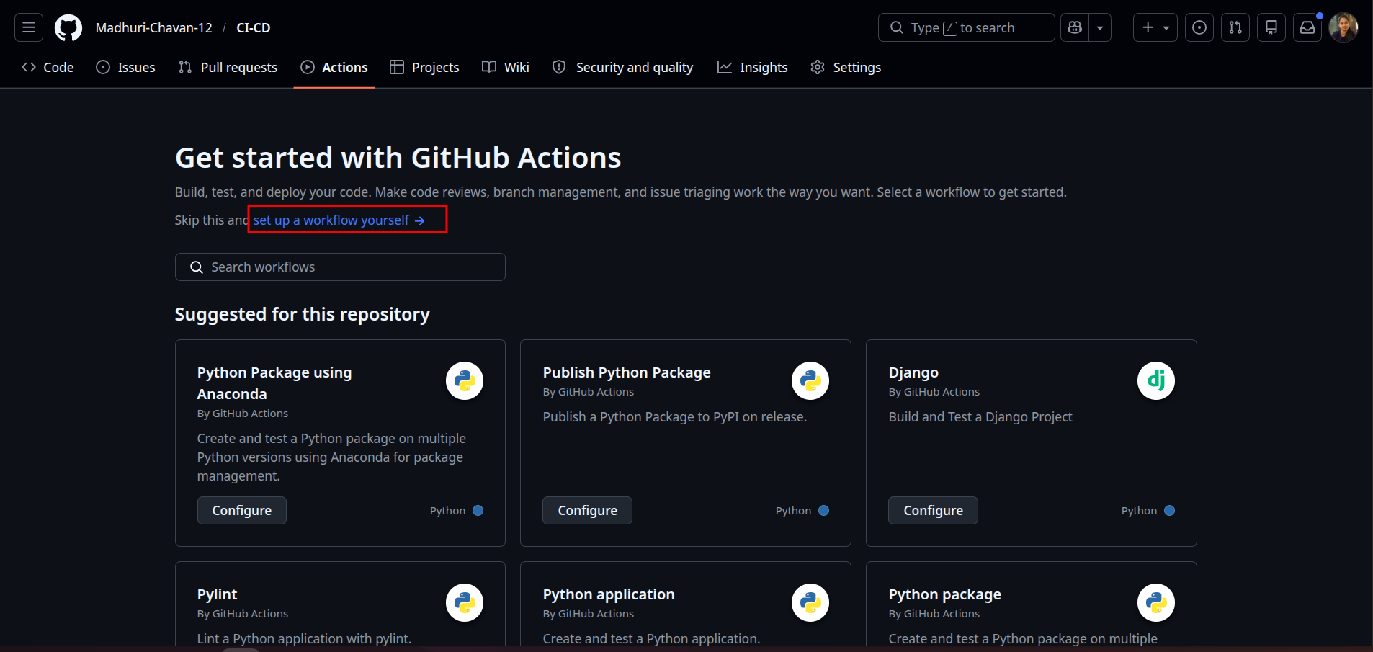

1.2 Create a new workflow file basic-workflow.yml with the below code, then click on Commit changes:

name: GitHub Actions Demo

run-name: Testing out GitHub Actions

on:
push:

jobs:
Basic-Workflow:
runs-on: ubuntu-latest

steps:
- run: echo "Job is executing as part of Basic workflow"

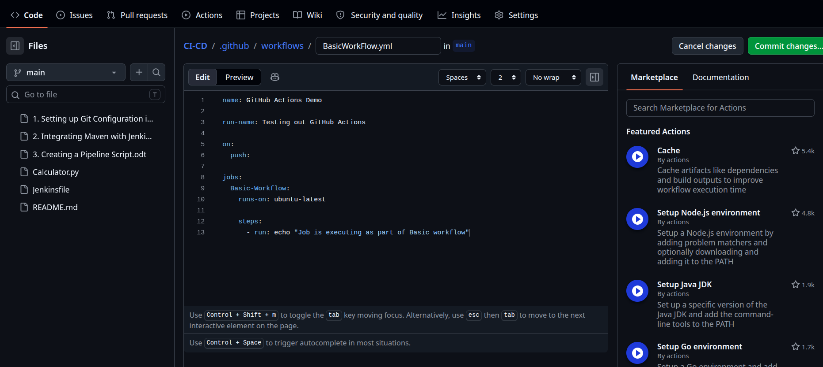

1.3 Add the Commit message as Create basic-workflow.yml and then click on Commit changes to save the workflow file in the code repository

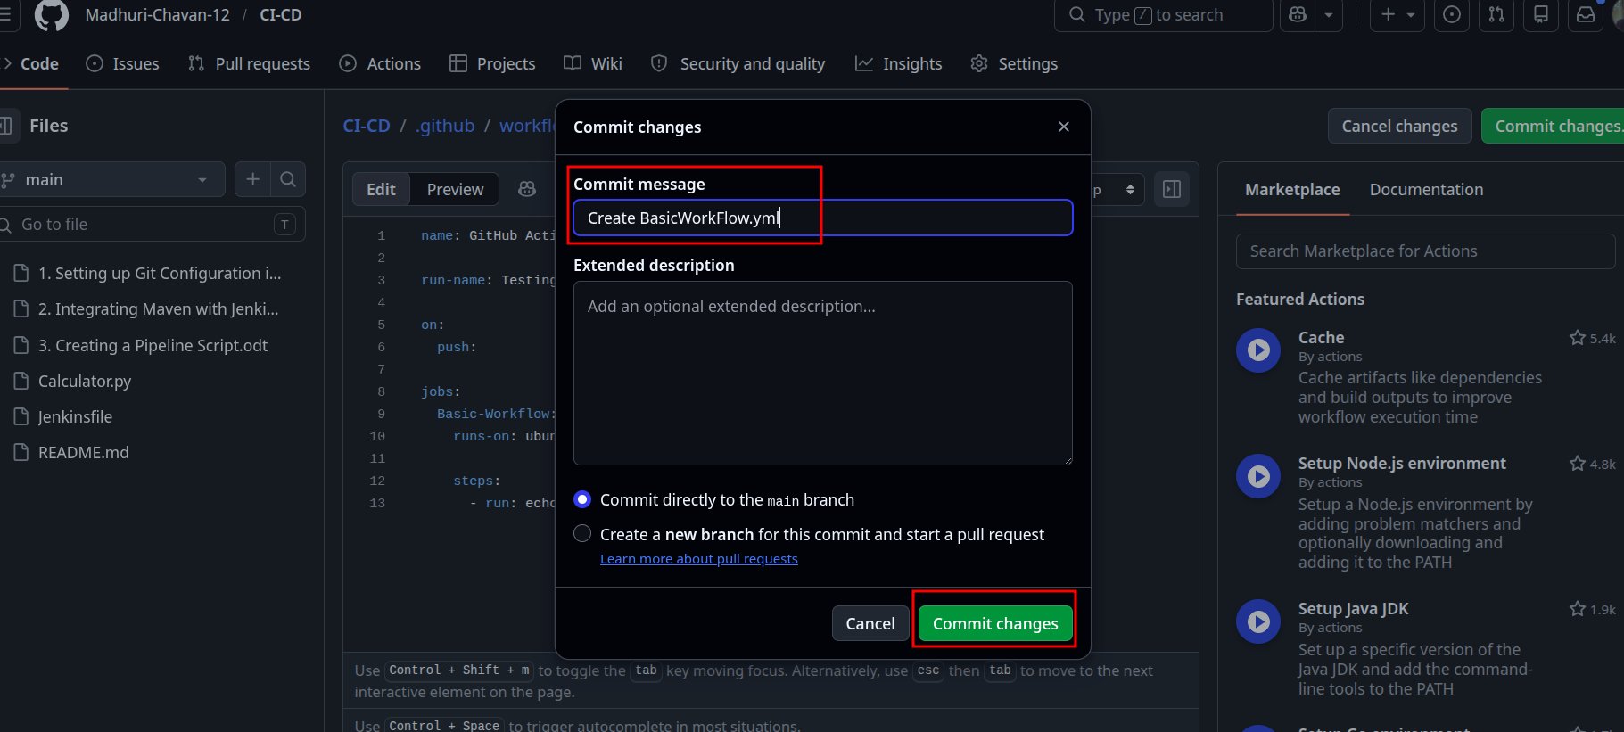

1.4 Navigate to the Actions tab to access the workflow execution, and under All workflows, click on the Testing out GitHub Actions

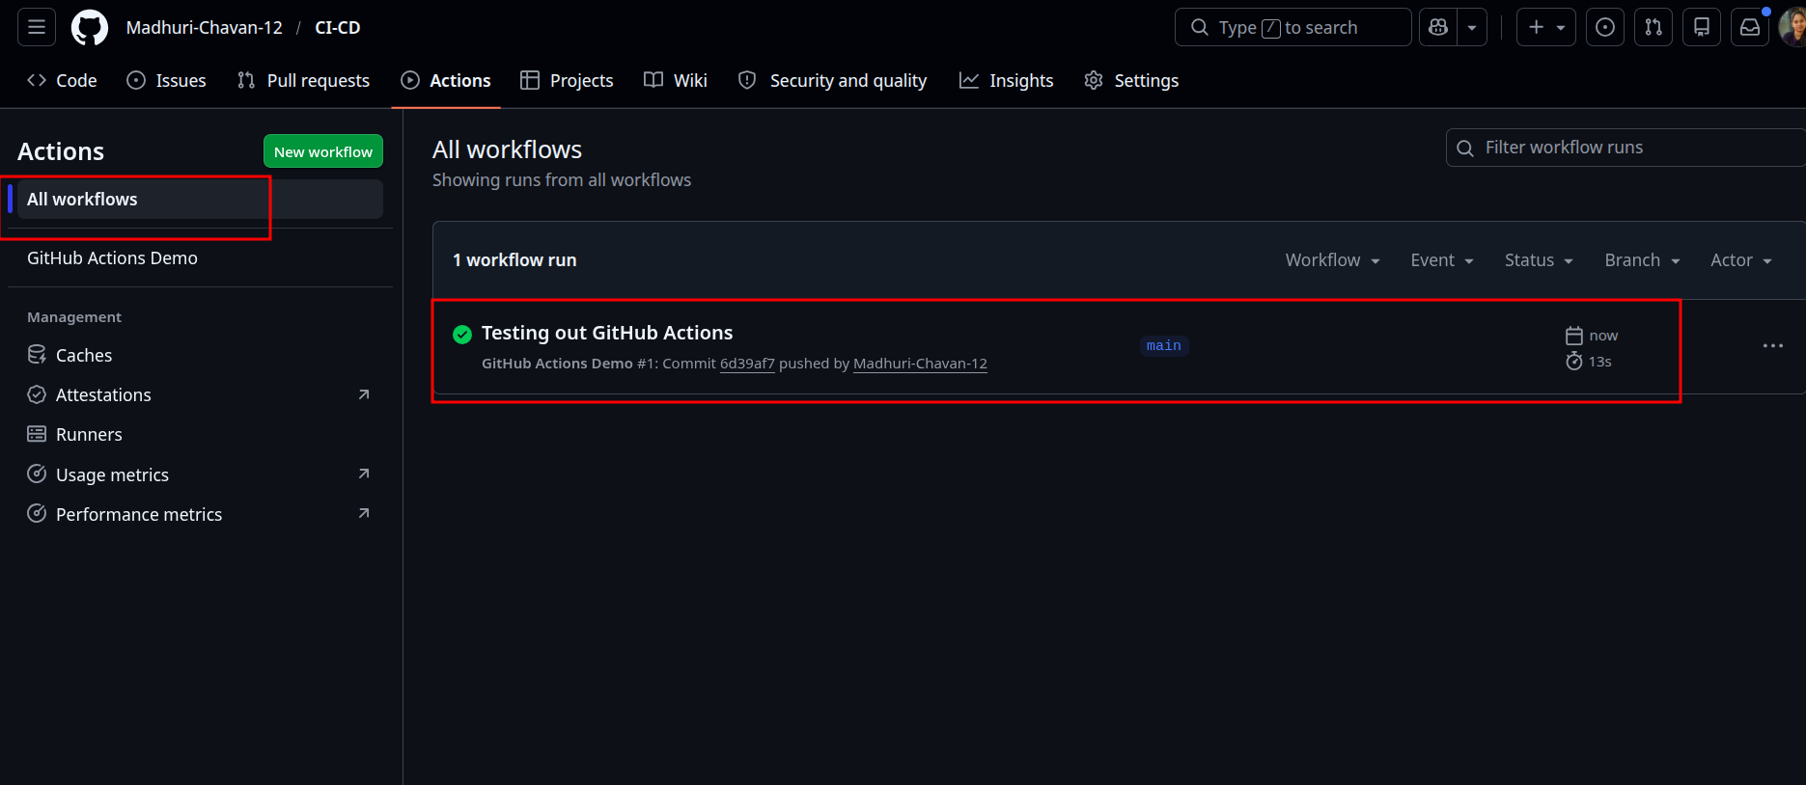
1.5 Click on the Basic-Workflow to view the job execution details

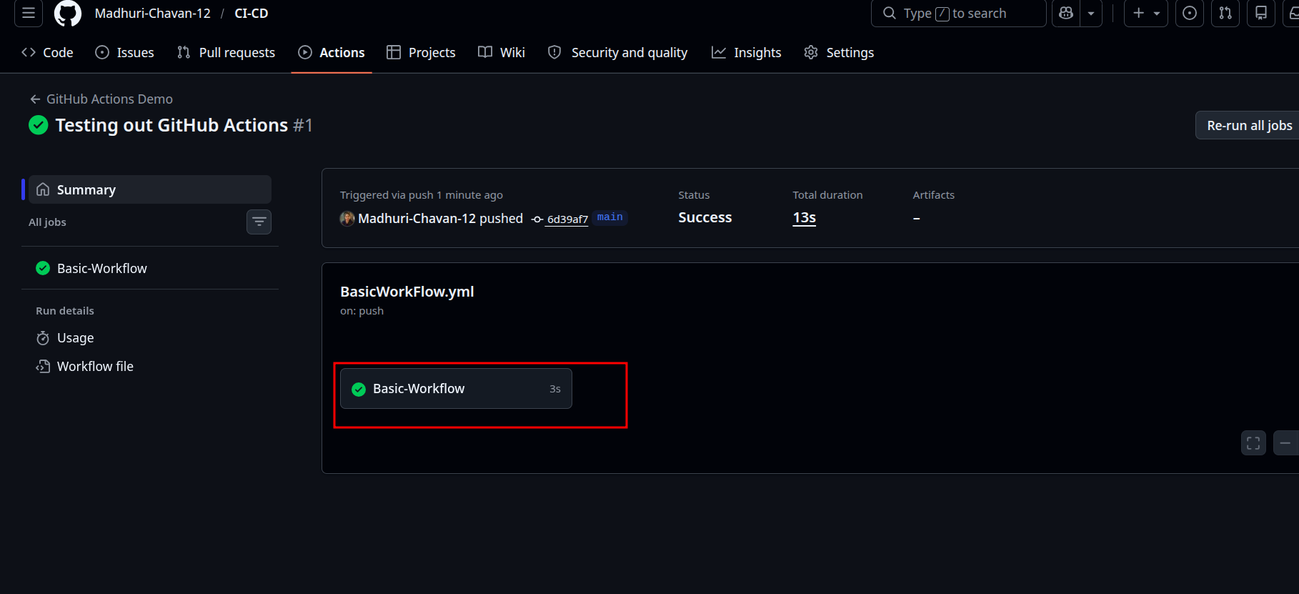

1.6 Expand the output under the Basic-Workflow

